**IoT 206: Microcontroller and Interfacing IoT Lab**

**Experiment-8:** Interfacing of MQ-2 Gas Sensor with Raspberry Pi.

**Components:**

1. npn transistor (2N5550)
2. Buzzer
3. LED-RED
4. LCD Display (LM016L)
5. LOGICSTATE
6. MQ-2 Gas Sensor
7. Raspberry Pi 3 (RPI3)

**Connection Diagram:**

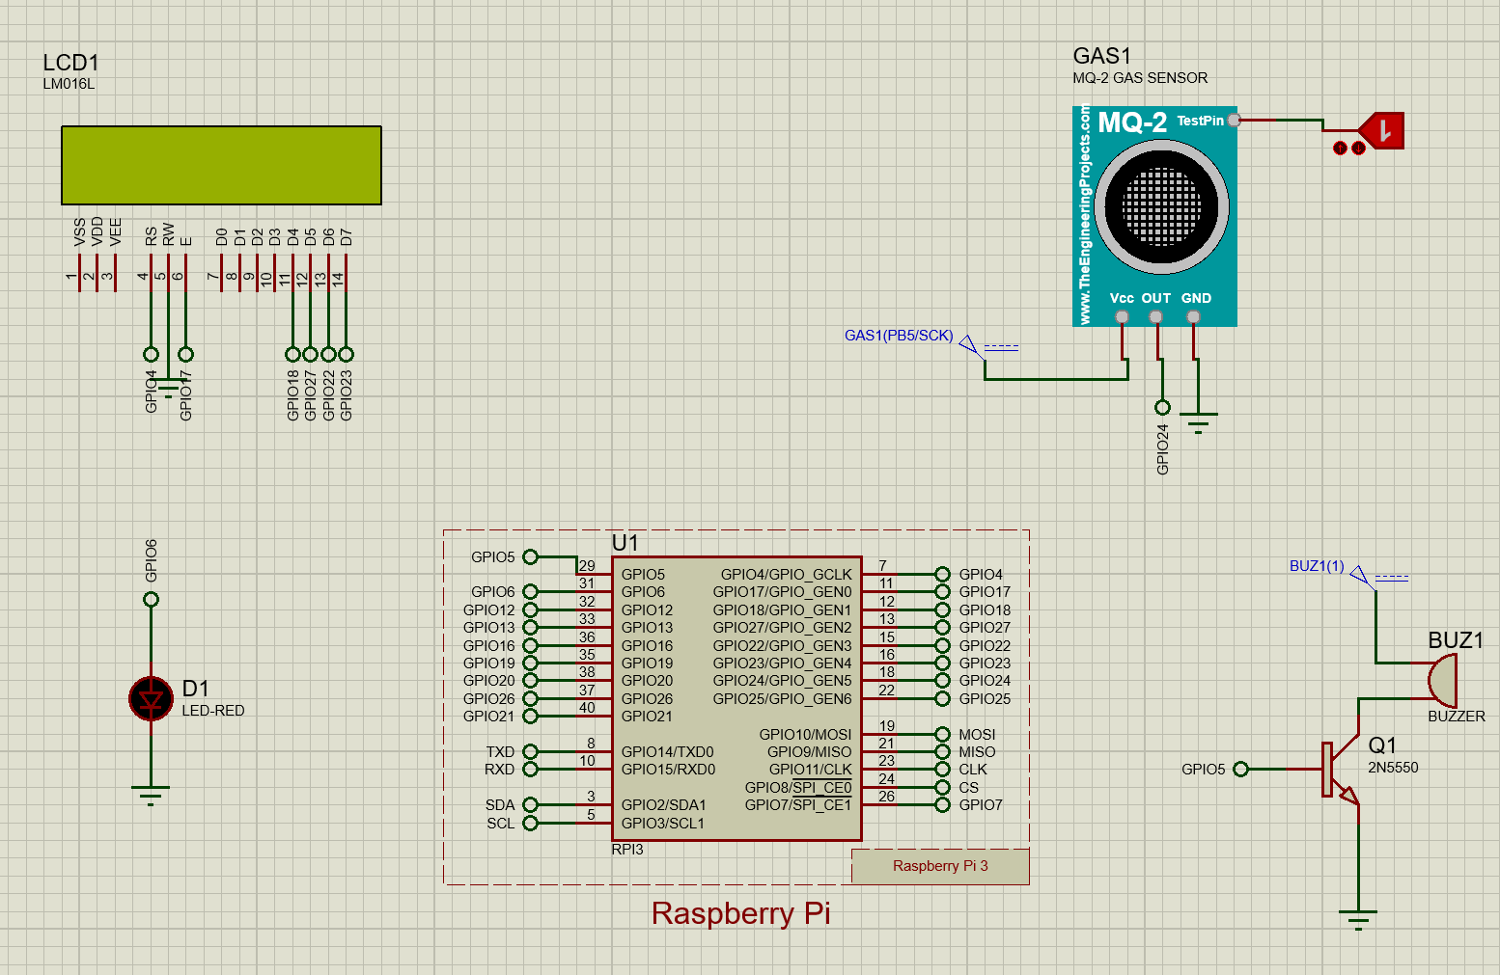

**Source Code:**

#!/usr/bin/python

import time

import RPi.GPIO as GPIO

GPIO.setmode(GPIO.BOARD)

GPIO.setwarnings(False)

'''

define pin for lcd

'''

# Timing constants

E_PULSE = 0.0005

E_DELAY = 0.0005

delay = 1

buzzer=37

GPIO.setup(buzzer, GPIO.OUT)

# Define GPIO to LCD mapping

LCD_RS = 7

LCD_E = 11

LCD_D4 = 12

LCD_D5 = 13

LCD_D6 = 15

LCD_D7 = 16

gas_Sensor = 18

red_light = 31

Buzzer= 29

GPIO.setup(LCD_E, GPIO.OUT) # E

GPIO.setup(LCD_RS, GPIO.OUT) # RS

GPIO.setup(LCD_D4, GPIO.OUT) # DB4

GPIO.setup(LCD_D5, GPIO.OUT) # DB5

GPIO.setup(LCD_D6, GPIO.OUT) # DB6

GPIO.setup(LCD_D7, GPIO.OUT) # DB7

GPIO.setup(gas_Sensor, GPIO.IN) # DB7

GPIO.setup(red_light, GPIO.OUT)

GPIO.setup(Buzzer, GPIO.OUT)

# Define some device constants

LCD_WIDTH = 16 # Maximum characters per line

LCD_CHR = True

LCD_CMD = False

LCD_LINE_1 = 0x80 # LCD RAM address for the 1st line

LCD_LINE_2 = 0xC0 # LCD RAM address for the 2nd line

'''

Function Name :lcd_init()

Function Description : this function is used to initialized lcd by sending the different commands

'''

def lcd_init():

# Initialise display

lcd_byte(0x33,LCD_CMD) # 110011 Initialise

lcd_byte(0x32,LCD_CMD) # 110010 Initialise

lcd_byte(0x06,LCD_CMD) # 000110 Cursor move direction

lcd_byte(0x0C,LCD_CMD) # 001100 Display On,Cursor Off, Blink Off

lcd_byte(0x28,LCD_CMD) # 101000 Data length, number of lines, font size

lcd_byte(0x01,LCD_CMD) # 000001 Clear display

time.sleep(E_DELAY)

'''

Function Name :lcd_byte(bits ,mode)

Fuction Name :the main purpose of this function to convert the byte data into bit and send to lcd port

'''

def lcd_byte(bits, mode):

# Send byte to data pins

# bits = data

# mode = True for character

# False for command

GPIO.output(LCD_RS, mode) # RS

# High bits

GPIO.output(LCD_D4, False)

GPIO.output(LCD_D5, False)

GPIO.output(LCD_D6, False)

GPIO.output(LCD_D7, False)

if bits&0x10==0x10:

GPIO.output(LCD_D4, True)

if bits&0x20==0x20:

GPIO.output(LCD_D5, True)

if bits&0x40==0x40:

GPIO.output(LCD_D6, True)

if bits&0x80==0x80:

GPIO.output(LCD_D7, True)

# Toggle 'Enable' pin

lcd_toggle_enable()

# Low bits

GPIO.output(LCD_D4, False)

GPIO.output(LCD_D5, False)

GPIO.output(LCD_D6, False)

GPIO.output(LCD_D7, False)

if bits&0x01==0x01:

GPIO.output(LCD_D4, True)

if bits&0x02==0x02:

GPIO.output(LCD_D5, True)

if bits&0x04==0x04:

GPIO.output(LCD_D6, True)

if bits&0x08==0x08:

GPIO.output(LCD_D7, True)

# Toggle 'Enable' pin

lcd_toggle_enable()

'''

Function Name : lcd_toggle_enable()

Function Description:basically this is used to toggle Enable pin

'''

def lcd_toggle_enable():

# Toggle enable

time.sleep(E_DELAY)

GPIO.output(LCD_E, True)

time.sleep(E_PULSE)

GPIO.output(LCD_E, False)

time.sleep(E_DELAY)

'''

Function Name :lcd_string(message,line)

Function Description :print the data on lcd

'''

def lcd_string(message,line):

# Send string to display

message = message.ljust(LCD_WIDTH," ")

lcd_byte(line, LCD_CMD)

for i in range(LCD_WIDTH):

lcd_byte(ord(message[i]),LCD_CHR)

lcd_init()

lcd_string("welcome ",LCD_LINE_1)

time.sleep(1)

# Define delay between readings

delay = 5

while 1:

# Print out results

if GPIO.input(gas_Sensor):

lcd_string("Gas Detected ",LCD_LINE_1)

GPIO.output(Buzzer, True)

GPIO.output(red_light, True)

else:

lcd_string("Gas Not Detected ",LCD_LINE_1)

GPIO.output(Buzzer, False)

GPIO.output(red_light, False)